**NAME : AWANTIKA KHATRI**

**STUDENT ID : BIT-24S-015**

**DEPARTMENT : INFORMATION TECHNOLOGY**

**SUBJECT : ARTIFICIAL TECHNOLOGY**

**LAB:1**

**TASK:1**

**Make 2-2 programs of each datatype.**

* **NUMERIC TYPES**

**INTEGAER(INT)**

**#progran 1**

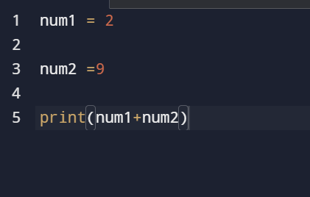

**OUTPUT**

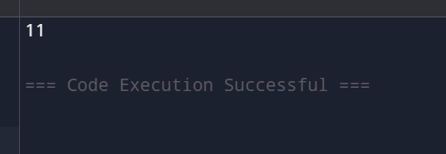

**#progran 2**

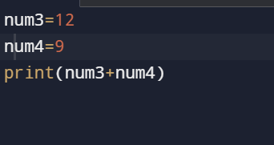

**OUTPUT**

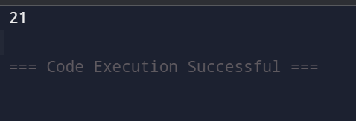

* **FLOATING-POINT(Float)**

**#Program 1**

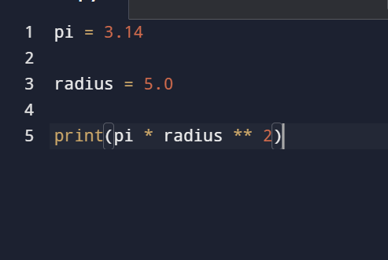

**OUTPUT**

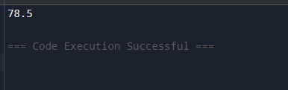

**#Program 2**

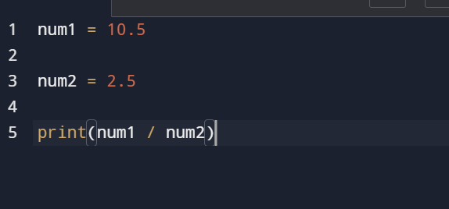

**OUTPUT**

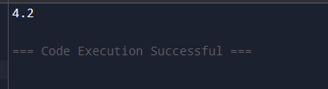

* **COMPLEX NUMBER**

**#Program 1**

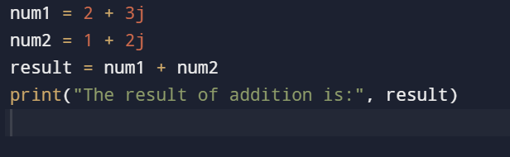

**OUTPUT**

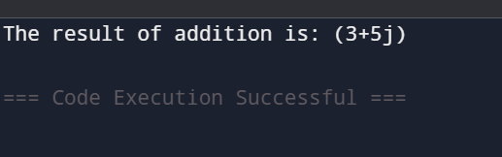

**# program 2**

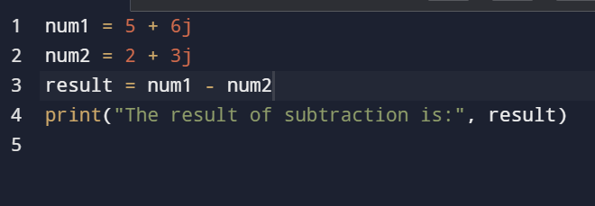

**OUTPUT**

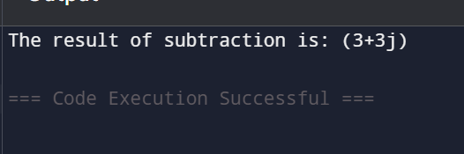

* **Sequence Types**

**String**

**#Program 1**

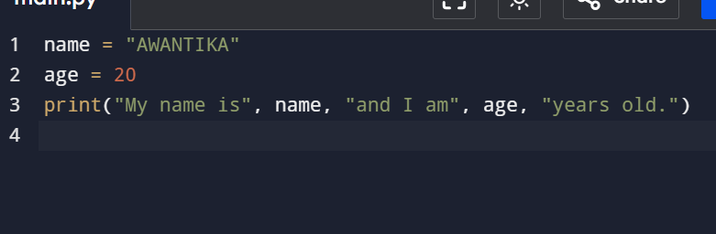

**OUTPUT**

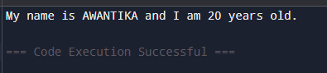

**#Program 2**

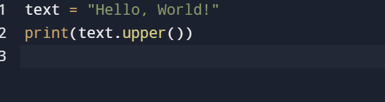

**OUTPUT**



* **List**

**#Program 1**

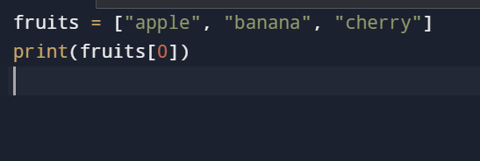

**OUTPUT**

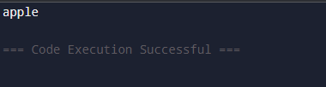

**#Program 2**

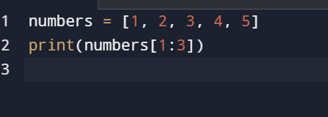

**OUTPUT**

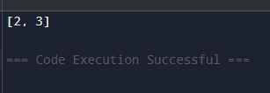

* **TUPLE(tuple):**

**#program 1**

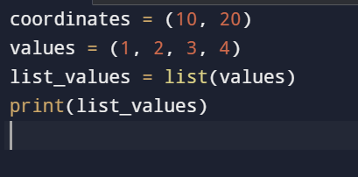

**OUTPUT**

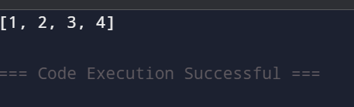

**#program 2**

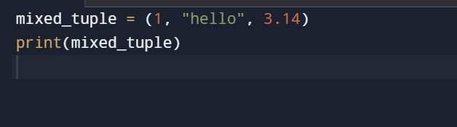

**OUTPUT**

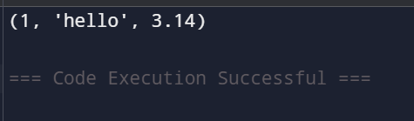

* **RANGE(range):**

**#PROGRAM 1**

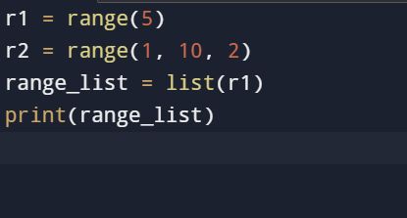

**OUTPUT**

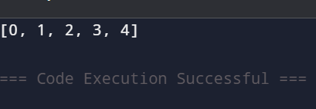

**#program 2**

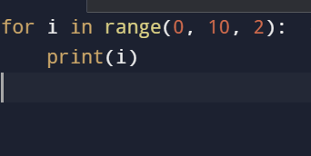

**OUTPUT**

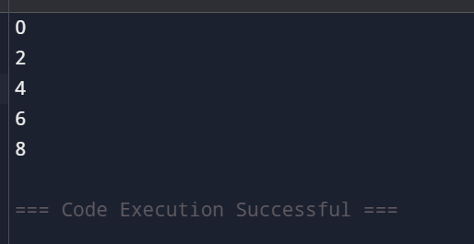

* **SETS TYPES**

**SET(sets)**

**#program 1**

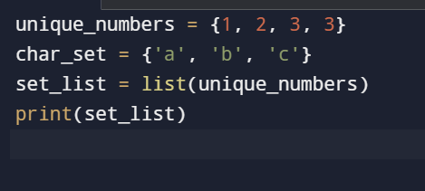

**OUTPUT**

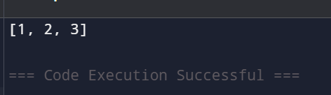

**#program 2**

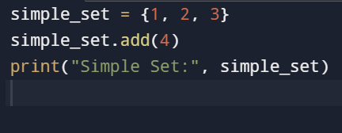

**OUTPUT**

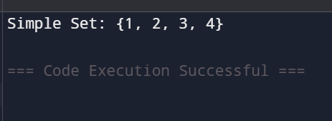

**FROZEN SETS(frozensets)**

**#program 1**

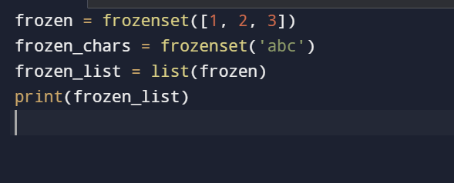

**OUTPUT**

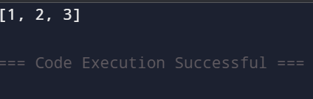

**#program 2**

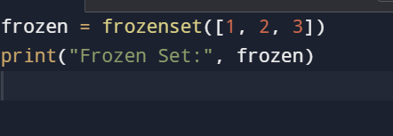

**OUTPUT**

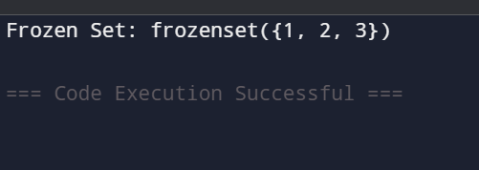

* **MAPPING TYPE**

**DICTIONARY(dict)**

**#program 1**

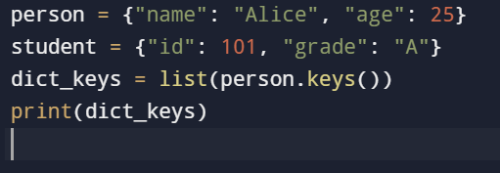

**OUTPUT**

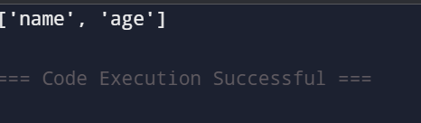

**#program 2**

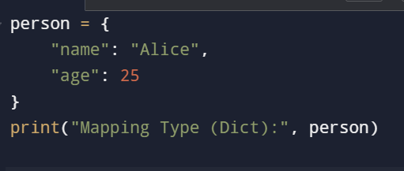

**OUTPUT**

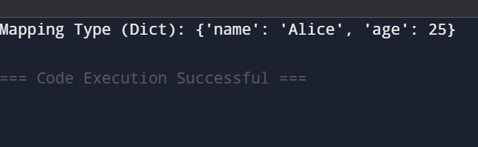

* **BOOLEAN TYPE**

**BOOLEAN(bool)**

**#program 1**

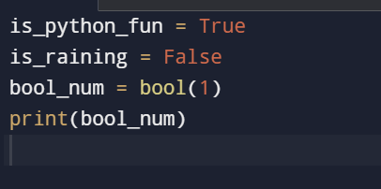

**OUTPUT**

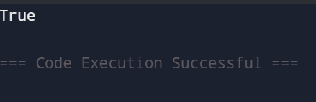

**#program 2**

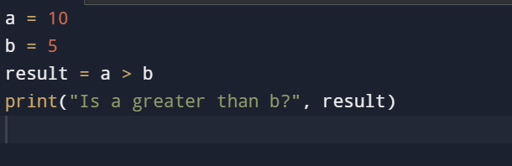

**OUTPUT**

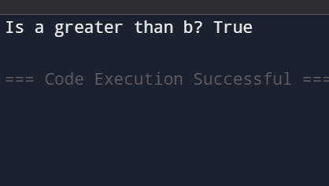

**TASK:2**

**Make up to 5 Shape programs using *.**

**Shape Programs**

**#Square**

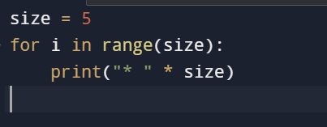

**OUTPUT**

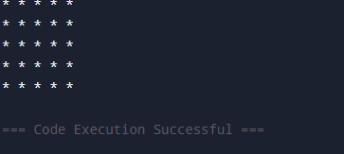

**#Rectangle**

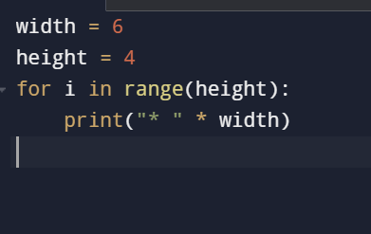

**OUTPUT**

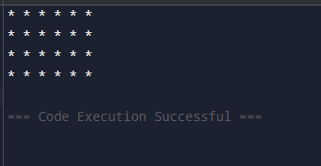

**#Triangle**

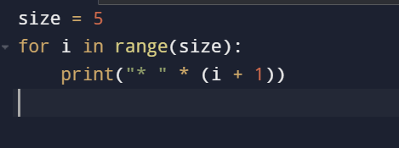

**OUTPUT**

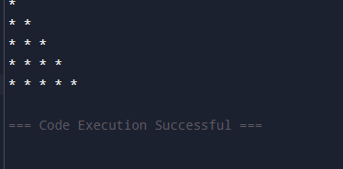

**#Diamond**

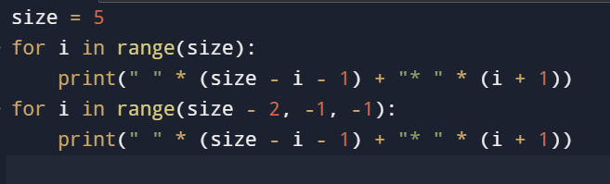

**OUTPUT**

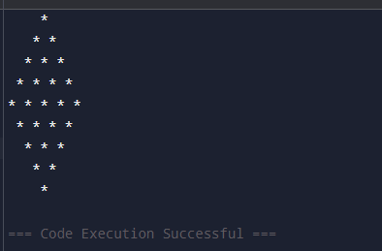

**#Circle**

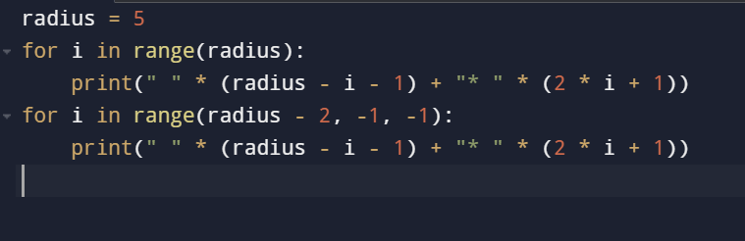

**OUTPUT**

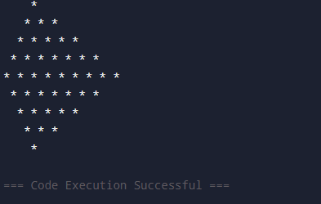

**TASK:3**

**Make same shapes you have made in task 2, using * mutiple by number.**

**#Square(Using Numbers)**

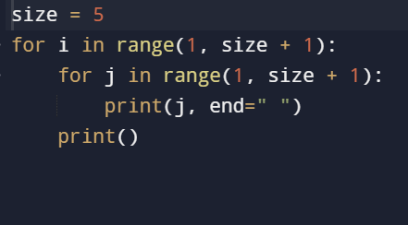

**OUTPUT**

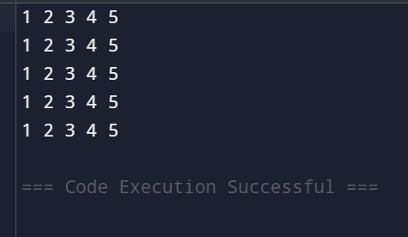

**#Rectangle(Using Numbers)**

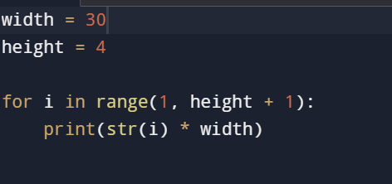

**OUTPUT**

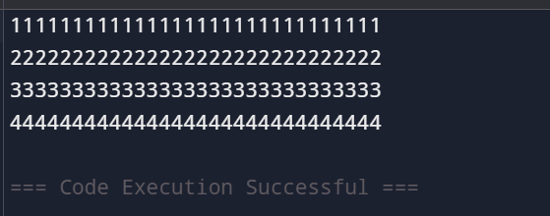

**#TRIANGLE(Using Numbers)**

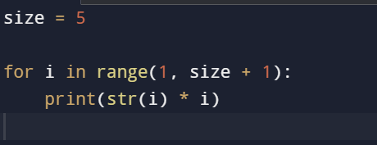

**OUTPUT**

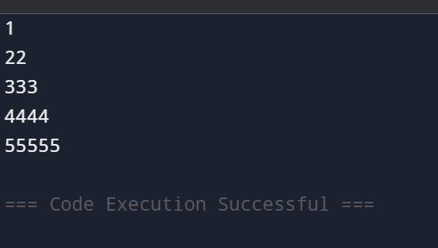

**# Diamond (Using Numbers)**

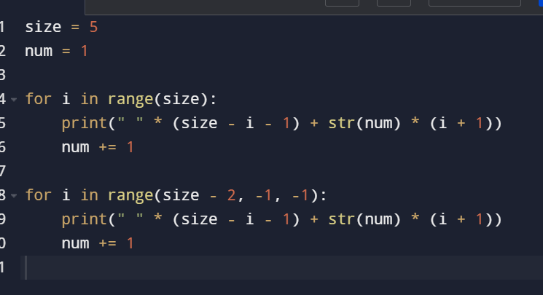

**OUTPUT**

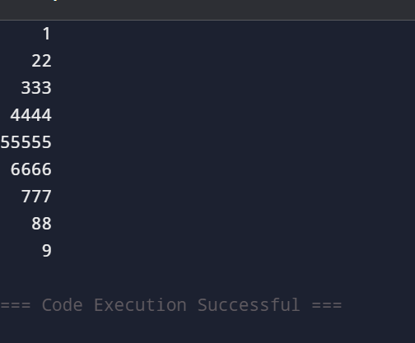

**#CIRCLE(Using Numbers)**

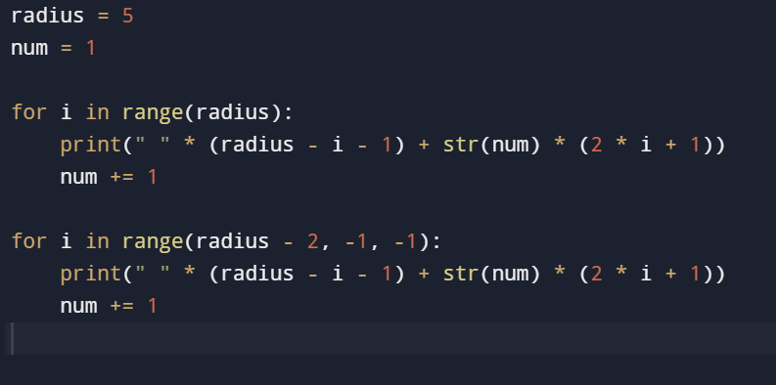

**OUTPUT**

